Fax Completed Order Blank to First Aid Bandage Company – (860) 442-8699
or
Scan and Send to CUSTOMERSERVICE@FABCO.NET

Sold to: (ID #: _________________ ) | Bill to: (ID #: _________________ ) | Ship to: (ID #:)________________ )
__________________________________  __________________________________  __________________________________  __________________________________ | __________________________________  __________________________________  __________________________________  __________________________________ | __________________________________  __________________________________  __________________________________  __________________________________

New  Customer  Information | Acc'ts Payable  Contact: | Contact’s Phone #:  Contact’s Fax #:

Ordered By* | Customer's PO # | Requested Date | Our Sales Order #
Tel #*:

Product  Code | Quantity | Description | Unit  Price
DROP SHIP Fee ($25.00) or,
EXPEDITE Fee ($15.00) (if applicable)
 |  | EXPRESS SHIPPING Cost (If applicable)

Credit Card: ◻ Visa ◻ Master Card | * Required Information for Credit Card Sales
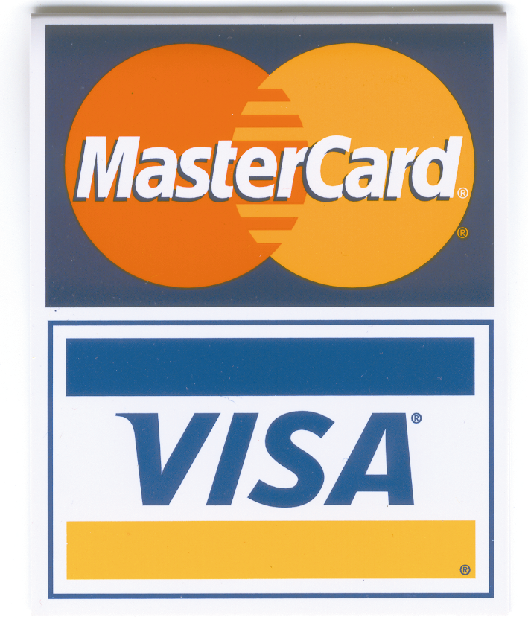Card Number*: ________________ - ________________ -________________ -________________
Expiration Date*: __________________________________ CSV Security Code*: ___________
Name on Card*: ___________________________________________________________________
Card Billing Address*: ____________________________________________________________________
Card Billing City & State*: _________________________________________________________
Card Billing Zip Code*: _______________________________________________________
Shipping Instructions:  (Circle Desired Method of Shipping) | OVERNIGHT  8 AM /Priority / Standard  (Add Expedite and Shipping Charges) | EXPRESS  2nd Day /3rd Day  (Add Expedite and Shipping Charges) | GROUND  (Free Shipping Charges within 48 Contiguous States)
Drop Ship Information  (Add Drop Ship Fee) | Reference This P/O #  on Packing List | Other

